**Homework III**

Name: Dazhi Li

RUID:197007456

Course: Sp.20 Software Engineering Web Application

Professor: Yinglung Liang

Source code:

import numpy as np

import matplotlib.pyplot as plt

from sklearn.preprocessing import PolynomialFeatures

import datetime

import pandas_datareader.data as web

def history_data(stock,start,end):

start_time = datetime.datetime.strptime(start, "%Y,%m,%d")

end = datetime.datetime.strptime(end,"%Y,%m,%d")

company = web.DataReader(stock, "yahoo", start_time, end)

return company

def SSE_mesure():

sum=0

for i in range(210):

sum+=(y[i]-y_train[i])**2

return sum

def R_square():

sum_1=SSE_mesure()

sum_2=0

for i in range(210):

sum_2+=(y_train[i]-y_train.mean())**2

R_square_value=1-(sum_1/sum_2)

return R_square_value

def Adj_R_square():

Adj_R_square_value=1-(((1-R_square())*(210-1))/(210-M-1))

return Adj_R_square_value

class Bayesian_curvefitiing():

def __init__(self, alpha=1., beta=1.):

self.alpha = alpha

self.beta = beta

self.mean_prev = None

self.S = None

def fit(self, X, t):

S_inv = self.alpha * np.eye(np.size(X, 1)) + self.beta * np.matmul(X.T,X)

mean_prev = np.linalg.solve(

S_inv,

self.beta * np.matmul(X.T,t)

)

self.mean_prev = mean_prev

self.S = np.linalg.inv(S_inv)

def predict(self, X):

y = np.matmul(X,self.mean_prev)

y_var = 1 / self.beta + np.sum(np.matmul(X,self.S) * X, axis=1)

y_std = np.sqrt(y_var)

return y, y_std

def Auto_adjusted_M(x_train,y_train,x_test):

scores=[]

for i in range(20):

poly_test = PolynomialFeatures(i)

X_train = poly_test.fit_transform(x_train)

X_test = poly_test.fit_transform(x_test)

model_test = Bayesian_curvefitiing(alpha=5e-3, beta=11.1)

model_test.fit(X_train, y_train)

y, y_std = model_test.predict(X_test)

sum_1 = 0

sum_2 = 0

for j in range(210):

sum_1 += (y[j] - y_train[j]) ** 2

sum_2 += (y_train[j] - y_train.mean()) ** 2

R_square_value = 1 - (sum_1 / sum_2)

score=1-(((1-R_square_value)*(210-1))/(210-i-1))

scores.append(score)

return scores

def early_stop(scores):

for i in range(20):

if scores[i+1]-scores[i]<=0.01 and scores[i+2]-scores[i-1]<=0.1:

return i

stockprice = history_data('AAPL', "2016,1,1", "2017,1,1")['Close'].to_list()

x_train = np.linspace(1, 210, 210)

x_train = x_train.reshape(-1, 1)

y_train = stockprice[:210]

y_train = np.array(y_train)

y_train = y_train.reshape(210)

x_test = np.linspace(1, 217, 217)

x_test = x_test.reshape(-1, 1)

y_test = stockprice[210:217]

y_test = np.array(y_test)

Ms=Auto_adjusted_M(x_train,y_train,x_test) #Polynomial degree

print(Ms)

M=early_stop(Ms)

print(M)

poly = PolynomialFeatures(M)

X_train = poly.fit_transform(x_train)

X_test = poly.fit_transform(x_test)

model = Bayesian_curvefitiing(alpha=5e-3, beta=11.1)

model.fit(X_train, y_train)

y, y_std = model.predict(X_test)

print(SSE_mesure())

print(R_square())

print(Adj_R_square())

fig = plt.figure()

plt.scatter(x_train, y_train, facecolor="none", edgecolor="b", s=20, label="training data")

plt.plot(x_train, y_train, c="b", label="trained stock price")

plt.plot(x_test, y, c="r", label="predicted stock price")

real_price=np.linspace(211,217,7).reshape(-1,1)

plt.plot(real_price, y_test, c="g", label="real stock price")

plt.scatter(real_price, y_test, c="g", s=20, label="real stock price")

plt.fill_between(x_test.flatten(), y - y_std, y + y_std, color="pink", label="std.", alpha=0.5)

plt.title("M="+str(M))

plt.legend(loc=2)

plt.show()

Predict result:

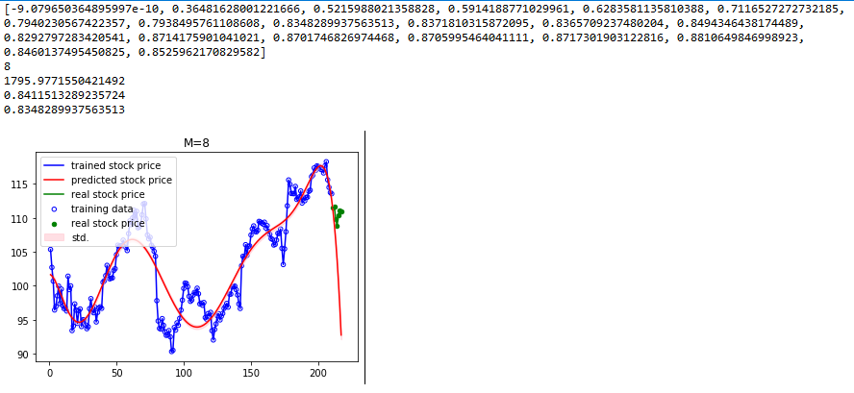

Figure 1

Stock price is downloaded by pandas-datareader. Here I use Apple Inc. as an example. The first 4 row of data means the adjusted R-square when M grows from 0 to 19. The best result without overfitting is when M=8. Red curve means fitted curve, blue and green curve means real stock price, but the blue is training data. Green is the testing data.

I tested 5 day stock price, there are 3 correct out of 5 total. The global accuracy is 0.63, precision is 0.46. Global means I collect data from other stocks in other times and calculate the prediction performance.

Running Requirement:

1. No .csv file needed, just run the code which will automatically download data from Yahoo-Finance!
2. Pandas-datareader package
3. Numpy
4. Matplotlib
5. Sklearn library

Adjust your own stock here:



‘AAPL’ refers to stock name

‘2016,1,1’ refers to start time of stock

‘2017,1,1’ refers to end time of stock

Adjust your training set and test set:

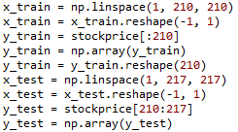

Please use python slice to slice a part for training set and another slice for testing set.